**18**

**Temperature**

|  |
| --- |
| **CHAPTER OUTLINE** |

18.1 Temperature and the Zeroth Law of Thermodynamics

18.2 Thermometers and the Celsius Temperature Scale

18.3 The Constant-Volume Gas Thermometer   
and the Absolute Temperature Scale

18.4 Thermal Expansion of Solids and Liquids

18.5 Macroscopic Description of an Ideal Gas

* An asterisk indicates a question or problem new to this edition.

|  |
| --- |
| **SOLUTIONS TO THINK-PAIR-SHARE AND ACTIVITIES** |

**\*TP18.1 Conceptualize** As the temperature increases, the pendulum on the clock will expand. We know from Chapter 15 that the period of a pendulum depends on its length. Therefore, we expect the timing of the clock to vary with temperature. (a) The pendulum will become longer as the temperature rises, making the period longer, so the clock will run slow and lose time during the week.

**Categorize** (b) We have no information about the structure of the pendulum. Let assume that it has some effective length *L*eff, which is the length of a simple pendulum with the same period.

**Analyze** We’ll use the symbol *Tp* for the period of the pendulum so we do not confuse this variable with *T* for the temperature. This period is given by Equation 15.26:

(1)



where *L*eff is the effective length of the equivalent simple pendulum with period *Tp*. We want to find a change in the period due to a change in the temperature. The change in the temperature will be related to a change in the length of the pendulum. Therefore, let us differentiate Equation (1) with respect to the pendulum length:

(2)



Multiply the fraction on the right of Equation (2) by unity in the form :



(3)



Because the change in period will be small, we can evaluate it as a differential from Equation (3):

(4)



The change in length will be due to a change in temperature, so use a differential form of Equation 18.5:

(5)



Substitute numerical values:



This is the time lost by the clock for each cycle of oscillation of the pendulum. To find the time lost in a week, multiply by the number of cycles in a week:



**Finalize** As we expected, it is a small effect. The clock loses less than a minute each week. Notice that we identified an effective length of the pendulum in the solution to the problem, but we never needed to substitute a numerical value for it. It canceled out in the generation of Equation (5).

*Answers:* (a) lose (b) 57.5 s

**\*TP18.2 Conceptualize** The copper power line has the same length at –25.0°C as the distance between the power poles, resulting in a line with essentially no sag. The power line will expand as the temperature rises. As a result, the line will sag, as discussed in the opening storyline for this chapter.

**Categorize** This is a thermal expansion problem.

**Analyze** The actual shape of the sagging power line can be modeled as a curve called a *catenary*. The catenary can be described mathematically, but such a discussion would likely be lost on a jury. Let’s assume an unrealistic shape for the power line that would give the absolute lowest possible height of a point on the line: the expanded power line is formed from two straight lines, forming right triangles: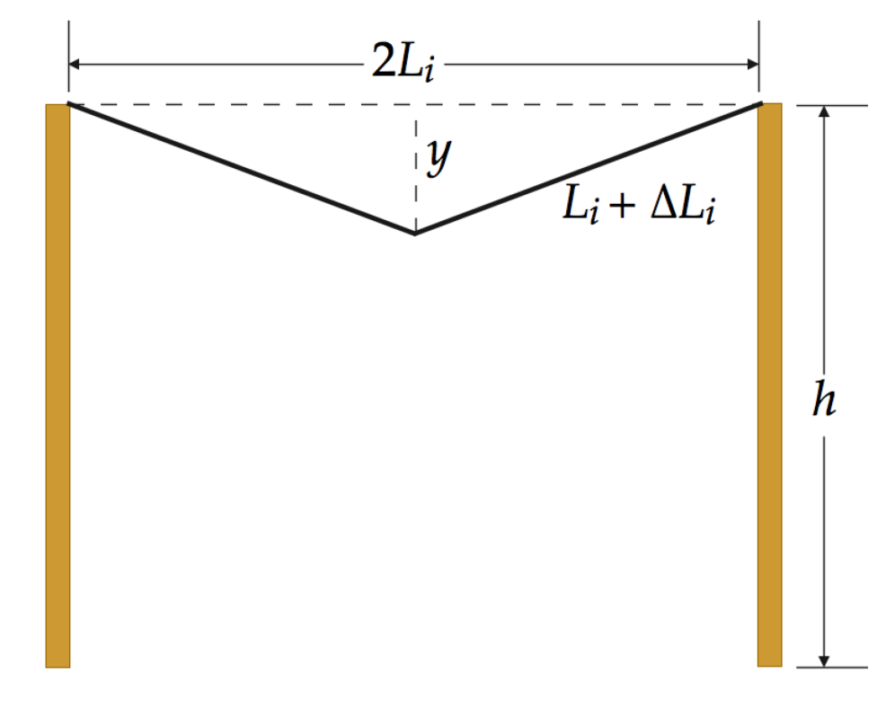

You could also argue to the jury that you could pull downward at the center of the power line to force it to take on the shape in the figure. The height of the lowest point you calculate will be lower than the actual height because you had to pull the center point *down* in order for the line to take on the triangular shape. As seen in the right half of the figure, half of the expanded power line acts as the hypotenuse of a right triangle, the vertical leg of the triangle is *y*, and the horizontal leg is half the initial length 2*Li* of the line. From the Pythagorean theorem,



Substitute numerical values:



Therefore the height of the lowest point on the power line is at a height above the roadway of:



**Finalize** The height of the lowest point on the expanded power line is still above the height clearance limit of 14.0 ft. Therefore, the truck must have been loaded too high. In the more realistic case of the power line forming a catenary, the lowest point on the line would be even higher than 15.1 ft above the roadway.

*Answers:* Answers will vary.

**\*TP18.3 Conceptualize** The primary idea for the mental representation is stated in the problem: “In order for the column of water to be suspended in the straw, the pressure above the column (within the straw) must be less than atmospheric pressure. For that to happen, the column of water must move downward a bit when the straw is raised from the water, so that the air above the column expands in volume, and the pressure decreases.”

**Categorize** The column of water is modeled as a *particle in equilibrium* in the vertical direction.

**Analyze** (a) Your measurements should be very close. However, based on the argument made in part (b), there should be a difference in the lengths.

(b) Part (a) of the diagram below shows on the left the straw in the water with the upper end open. On the right, the straw has been raised out of the cup with the finger on the upper end and placed next to the container of water in order to compare the height of the water in the container to the length of the plug of water in the straw.

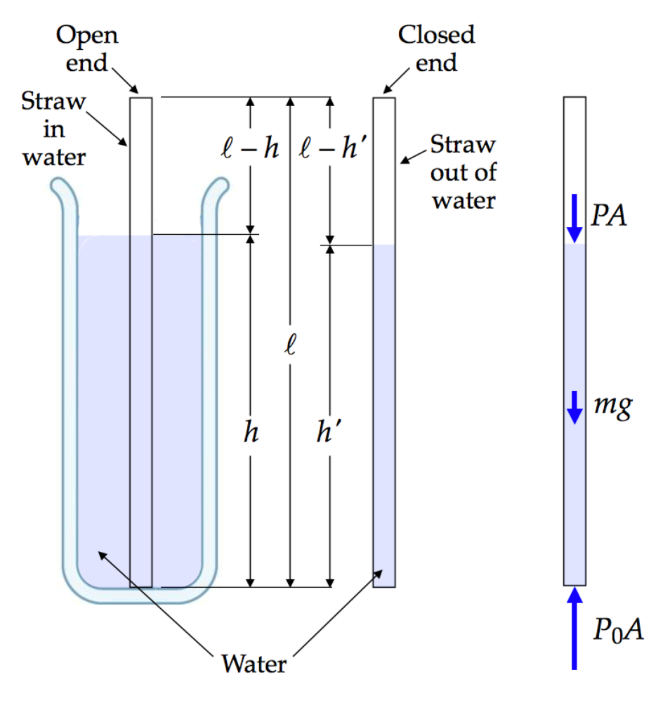

(a) (b)

**Fig. ANS TP18.3**

Part (b) of the diagram shows the forces on the plug of water in the straw from the inside air, the outside air, and gravity. Apply the particle in equilibrium model to the plug of water of length *h*′ when it is suspended in the straw:

(1)



where *A* is the cross-sectional area of the straw, *m* is the mass of the plug of water, and *P* is the pressure of the air inside the straw above the water. Solve Equation (1) for *P* and incorporate Equation 1.1 for the water:

(2)



Now, considering Equation 18.9, we have not changed the temperature of the air in the straw above the water, so, applying the ideal gas law to the air between the finger and the plug of water,



Substitute Equation (2) into Equation (3) and simplify:

(4)



Equation (4) is a quadratic equation whose only possible solution is

(5)



The other solution,



gives *h*′ > , which is not physically possible.

(c) The results of evaluating Equation (5) for the values of *h* suggested appear below.

|  |  |  |  |
| --- | --- | --- | --- |
| ***h* (cm)** | ***h*′ (cm)** | ***h – h*′ (mm)** | **% difference** |
| 0 | 0 | 0 | — |
| 1 | 0.97 | 0.273 | 2.7 |
| 2 | 1.95 | 0.528 | 2.6 |
| 3 | 2.92 | 0.766 | 2.6 |
| 4 | 3.90 | 0.985 | 2.5 |
| 5 | 4.88 | 1.19 | 2.4 |
| 6 | 5.86 | 1.37 | 2.3 |
| 7 | 6.85 | 1.53 | 2.2 |
| 8 | 7.83 | 1.68 | 2.1 |
| 9 | 8.82 | 1.81 | 2.0 |
| 10 | 9.81 | 1.92 | 1.9 |
| 11 | 10.8 | 2.01 | 1.8 |
| 12 | 11.8 | 2.08 | 1.7 |
| 13 | 12.8 | 2.13 | 1.6 |
| 14 | 13.8 | 2.16 | 1.5 |
| 15 | 14.8 | 2.18 | 1.5 |
| 16 | 15.8 | 2.17 | 1.4 |
| 17 | 16.7 | 2.15 | 1.3 |
| 18 | 17.8 | 2.10 | 1.2 |
| 19 | 18.8 | 2.04 | 1.1 |
| 20 | 19.8 | 1.95 | 1.0 |
| 21 | 20.8 | 1.85 | 0.9 |
| 22 | 21.8 | 1.73 | 0.8 |
| 23 | 22.9 | 1.58 | 0.7 |
| 24 | 23.9 | 1.42 | 0.6 |
| 25 | 24.9 | 1.23 | 0.5 |
| 26 | 25.9 | 1.03 | 0.4 |
| 27 | 26.9 | 0.802 | 0.3 |
| 28 | 27.9 | 0.556 | 0.2 |
| 29 | 29.0 | 0.288 | 0.1 |
| 30 | 30.0 | 0 | 0.0 |

(d) The fourth column of the table shows the percentage difference. Therefore, we see the largest percentage difference in *h* and *h*′ for *small* values of *h*.

(e) The table of values shows the largest value of *h* – *h*′ to be at *h* = 15 cm. Let’s see if that value is exact. Express Equation (5) as

(6)



where



Using Equation (5), differentiate the quantity *h* – *h*′ to find the value of *h* at which this quantity maximizes:



Set this derivative equal to zero to find the value of *h*max at which *h* – *h*′ maximizes:



Square both sides and solve for *h*max:



Substitute numerical values:



Therefore, the quantity *h* – *h*′ maximizes *near* the center of the straw but not *exactly at* the center.

**Finalize** There is some interesting behavior to observe in the table. Notice that the difference *h – h*’ begins at zero for small values of *h*, reaches a maximum near *h* = 15.0 cm, and then decreases again to zero. For small values of *h*, the plug of suspended water has very little mass, so the air above the plug does not have to expand very much in order for the pressure to drop sufficiently to support it. On the other hand, at large values of *h*, while the mass of the plug is large, a small drop in the level of the upper surface of the plug represents a large percentage difference in the volume of the air, so only a small decrease in level is sufficient to drop the pressure sufficiently. In between, the competing effects of plug mass and initial volume of air balance to maximize the difference near *h* = 15 cm.

Despite the fact that *h – h*’ has a maximum near *h* = 15 cm, notice that the percentage change in *h* starts large near *h* = 0 and falls steadily. In particular, notice that the difference in the middle regions is only about 1.5%. This might be less than your uncertainty in your measurement of the length of the plug in part (a), so you may not have detected any difference.

*Answers:* (a) Answers will vary. (b) See solution.

(c)

|  |  |
| --- | --- |
| ***h* (cm)** | ***h – h*’ (mm)** |
| 0 | 0 |
| 1 | 0.273 |
| 2 | 0.528 |
| 3 | 0.766 |
| 4 | 0.985 |
| 5 | 1.19 |
| 6 | 1.37 |
| 7 | 1.53 |
| 8 | 1.68 |
| 9 | 1.81 |
| 10 | 1.92 |
| 11 | 2.01 |
| 12 | 2.08 |
| 13 | 2.13 |
| 14 | 2.16 |
| 15 | 2.18 |
| 16 | 2.17 |
| 17 | 2.15 |
| 18 | 2.10 |
| 19 | 2.04 |
| 20 | 1.95 |
| 21 | 1.85 |
| 22 | 1.73 |
| 23 | 1.58 |
| 24 | 1.42 |
| 25 | 1.23 |
| 26 | 1.03 |
| 27 | 0.802 |
| 28 | 0.556 |
| 29 | 0.288 |
| 30 | 0 |

(d) small values (e) 15.2 cm

|  |
| --- |
| **SOLUTIONS TO END-OF-CHAPTER PROBLEMS** |

Section 18.2 Thermometers and the Celsius Temperature Scale

**\*P18.1 Conceptualize** Notice that the new temperature scale is not that far off from the Fahrenheit scale at human body temperature, but differs significantly at the freezing point of water.

**Categorize** This problem involves finding a conversion equation between °F and °N, similar to Equation 18.2 for the Celsius and Fahrenheit scales.

**Analyze** Following the lead of Equation 18.2, we expect a linear relationship between the New and Fahrenheit scales:

(1)



where we need to determine *a* and *b*. Substitute numerical values into Equation (1) for the freezing point of water:

(2)



Do the same for normal human body temperature:

(3)



Substitute Equation (2) into Equation (3) and solve for *a*:

(4)



Now use Equation (2) to find *b*:

(5)



Therefore, Equation (1) can be written

(6)



Use Equation (6) to find the temperatures requested by your professor on the New scale:

(a) Absolute zero:



(b) Melting point of mercury:



(c) Boiling point of water:



(d) Hottest weather temperature on record:



**Finalize** It is hard to see what advantage this scale has over other scales. Tying a specific reference temperature such as 100°N to a particular organism on the Earth does not seem as natural as defining a point on a scale according to a universally available element or substance, such as water.

*Answers:* (a) –738°N (b) –105°N (c) 270°N (d) 153°N

Section 18.3 The Constant-Volume Gas Thermometer and the Absolute Temperature Scale

**P18.2** (a) By Equation 18.2,



(b)



**P18.3** (a) By Equation 18.2,



And, from Equation 18.1,



(b) Again,



**P18.4** (a) By Equation 18.2,



(b) Applying Equation 18.1,



**P18.5** (a) To convert from Fahrenheit to Celsius, we use



The temperature at Furnace Creek Ranch in Death Valley is



and the temperature at Prospect Creek Camp in Alaska is



(b) We find the Kelvin temperature from Equation 18.1,  
*T* = *TC* + 273.15. The record temperature on the Kelvin scale at Furnace Creek Ranch in Death Valley is



and the temperature at Prospect Creek Camp in Alaska is



**Section 18.4 Thermal Expansion of Solids and Liquids**

**P18.6** The horizontal section expands according to



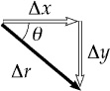

**ANS. FIG. P18.6**

The vertical section expands similarly by



The vector displacement of the pipe elbow has magnitude



and is directed to the right below the horizontal at angle



**P18.7** The wire is 35.0 m long when *TC* = −20.0°C.



Since for Cu,



**P18.8** For the dimensions to increase,



**P18.9** By Equation 18.5,



The expansion can be compensated for by mounting the pipeline on rollers and placing -shaped loops between straight sections. They bend as the steel changes length.



**P18.10** (a) Following the logic in the textbook for obtaining Equation 18.7 from Equation 18.5, we can express an expansion in area as



(b) The length of each side of the hole has increased. Thus, this represents an in the area of the hole.



**\*P18.11** **Conceptualize** The spans will expand as the temperature rises. No room for this expansion has been allowed, so the buckling will occur as a result.

**Categorize** This is a thermal expansion problem.

**Analyze** As seen in Figure P18.11b, the expanded span acts as the hypotenuse of a right triangle, the vertical leg of the triangle is *y*, and the horizontal leg is half the initial length of the span. From the Pythagorean theorem,



Substitute numerical values:



**Finalize** This is a serious engineering flaw and must be corrected by leaving an expansion gap between the spans. To determine the gap that is needed between adjacent spans of concrete, we note that span of length *L* expands by



A total gap of only 6.00 cm would accommodate the expansion of both spans of concrete.

*Answer:* 2.74 m

**\*P18.12** **Conceptualize** The spans will expand as the temperature rises. No room for this expansion has been allowed, so the buckling will occur as a result.

**Categorize** This is a thermal expansion problem.

**Analyze** As seen in Figure P18.11b, the expanded span acts as the hypotenuse of a right triangle, the vertical leg of the triangle is *y*, and the horizontal leg is half the initial length of the span. From the Pythagorean theorem,



**Finalize** This is a serious engineering flaw and must be corrected by leaving an expansion gap between the spans.

*Answer:*



**P18.13** (a) By Equation 18.5, , and



which gives



(b) We must get *L*Al = *L*Brass for some or



Solving for



so



(c)



**P18.14** We solve for the temperature *T* at which the brass ring would fit over the aluminum cylinder.



The situation is impossible because the



**P18.15** (a) The original volume of the acetone we take as precisely 100 mL. After it is finally cooled to 20.0°C, its volume is



(b) Initially, the volume of the acetone reaches the 100-mL mark on the flask, but the acetone cools and the flask warms to a temperature of 32.0 °C. Thus, the volume of the acetone decreases and the volume of the flask increases. This means the acetone will be below the 100-mL mark on the flask.

**P18.16** (a) The material would expand by or but instead feels stress



(b) The stress is less than the compressive strength, so



**P18.17** We model the wire as contracting according to and then stretching according to



(a) We find the tension from



(b)



To increase the stress the temperature must decrease to .



(c)



**Section 18.5 Macroscopic Description of an Ideal Gas**

**P18.18** When the tank has been prepared and is ready to use it contains 1.00 L of air and 4.00 L of water. Consider the air in the tank during one discharge process. We suppose that the process is slow enough that the temperature remains constant. Then as the pressure drops from 2.40 atm to 1.20 atm, the volume of the air doubles (*PV* ≈ constant) resulting in 1.00 L of water expelled and 3.00 L remaining. In the second discharge, the air volume doubles from 2.00 L to 4.00 L and 2.00 L of water is sprayed out. In the third discharge, only the last 1.00 L of water comes out.



**P18.19** The equation of state of an ideal gas is *PV* = *nRT,* so we need to solve for the number of moles to find *N*.



Then,



**P18.20** (a) From *PV* = *nRT*, we obtain . Then



(b)



(c)



(d) The to hit the walls hard.



**P18.21** (a) From the ideal gas law, *PV* = *nRT*, so



(b)



(c) of 1.20 kg/m3 at 20.0°C.



**P18.22** One mole of helium contains Avogadro’s number of molecules and has a mass of 4.00 g. Let us call the mass of one atom, and we have



or



**P18.23** We use Equation 18.11, *PV* = *NkBT*:



**\*P18.24** **Conceptualize** The means by which oxygen could be recovered from carbon dioxide is a variation of a process called the *Sabatier reaction* and proceeds as follows:

CO2 + 2H2O → CH4 + 2O2

**Categorize** We are given a volume and a temperature of a gas, and are asked to find the pressure, so we will use the ideal gas law for the calculation.

**Analyze** The number of moles of a gas can be related to the mass of the gas from Equation 18.8:

(1)



Over a time interval ∆*T*, a certain number of moles ∆*n* will be generated as follows:

(2)



Substitute numerical values to find the amount of carbon dioxide generated by three astronauts in one week:



In the reaction, 1.00 mole of carbon dioxide results in 1.00 mole of methane, so 520 mol of methane is produced in one week. Use the ideal gas law, Equation 18.9, to find the pressure in the methane tank:



**Finalize** This pressure represents about 65 times the atmospheric pressure on Earth. As mentioned in the problem statement, this gas can be expelled to adjust the orientation of the spacecraft.

*Answer:* 6.58 × 106 Pa

**P18.25** The density of the air inside the balloon, must be reduced until the buoyant force of the outside air is at least equal to the weight of the balloon plus the weight of the air inside it:



where *V* = 400 m3, and *mb* = 200 kg.



From *PV* = *nRT*, . This equation means that at constant pressure the density is inversely proportional to the temperature. Thus, the density of the hot air inside the balloon is



Substituting this result into the condition gives



**P18.26** To compute the mass of air leaving the room, we begin with the ideal gas law:



As the temperature is increased at constant pressure,



Subtracting the two equations gives



**P18.27** My bedroom is 4 m long, 4 m wide, and 2.4 m high, enclosing air at   
100 kPa and 20°C = 293 K. Think of the air as 80.0% N2 and 20.0% O2.

Avogadro’s number of molecules has mass



Then gives



**\*P18.28 Conceptualize** In scenario (i), the volume of the air interior to the bell is allowed to vary freely as the bell descends, resulting in water entering the bottom of the bell. Therefore, the volume of the working area inside the bell is decreasing. In scenario (ii), additional air is delivered to the interior of the bell, pushing the water out. This requires mounting the extra tanks before taking the dive.

**Categorize** We see that we will need our pressure–depth relationship from Chapter 14. We will also model the air in the bell as ideal, so we can use the ideal gas law.

**Analyze** We analyze scenario (i) first.From Equation 14.4, we know that the water pressure at a given depth *h* in the seawater is

(1)



This high pressure will cause water to enter the bottom of the bell. The air in the bell will be compressed to a smaller volume until its pressure is enough to balance that of the water. Use Equation 18.9 to relate the initial thermodynamic variables for the air (when the bell is at the surface) with the final values at depth *h*:

(2)



Solve this equation for the final volume of the air in the bell:

(3)



Substitute atmospheric pressure for the initial value and Equation (1) for the final pressure:

(4)



Substitute numerical values:



This scenario looks terrible! The available water-free space in the bell has shrunk by 84%, so the humans must squeeze into that small volume to work. In addition, any sensitive electronic equipment must be kept at the very upper end of the bell so that it is not damaged by water. Because the bell is a cylinder with a fixed cross section, we can find the vertical height in which the humans can work:



Therefore, the humans have a choice: they can suspend themselves horizontally in the 40.0 cm of air available above the water, or they can orient themselves vertically with most of their bodies in the water, as is the case with a device called a *wet bell*.

Now, what about scenario (ii)? Here, we pump in high-pressure air to push against the water attempting to enter the bottom of the bell. With the right adjustment of the air pressure in the bell, the entire interior volume of the bell remains dry for the inhabitants to perform their experiments.

For this situation, scenario (ii) looks best. While it will cost more, and the equipment will be subject to mechanical failure, the installation of the equipment to provide the high-pressure air will keep the interior of the bell dry.

**Finalize** In both scenarios, the humans are working at high air pressure, either because the air has been compressed by water in scenario (i) or because of the introduction of high-pressure air in scenario (ii). Therefore, they would need to breathe a mixture of helium and oxygen so that the partial pressure of oxygen remains low enough to avoid oxygen toxicity. In addition, there may be decompression issues when the inhabitants of the bell are raised back to the surface. While we found that scenario (ii) was better for deep dives, the water pressure will increase by a smaller amount for shallow dives, so that only a small portion of the interior volume will be filled with water. It may be advantageous in that case to spare the money and effort for the tanks and choose scenario (i). Answer: Scenario (ii) is better for a dive of this depth.

**P18.29** If *Pgi* is the initial gauge pressure of the gas in the cylinder, the initial absolute pressure is *P*i,abs = *Pgi* + *P*0, where *P*0 is the exterior pressure. Likewise, the final absolute pressure in the cylinder is *P*f,abs = *Pgf* + *P*0, where *Pgf* is the final gauge pressure. The initial and final masses of gas in the cylinder are *mi* = *ni M* and *mf* = *nf M*, where *n* is the number of moles of gas present and *M* is the molecular weight of this gas. Thus, .



We assume the cylinder is a rigid container whose volume does not vary with internal pressure. Also, since the temperature of the cylinder is constant, its volume does not expand or contract. Then, the ideal gas law (using absolute pressures) with both temperature and volume constant gives

or



and in terms of gauge pressures,



**Additional Problems**

**P18.30** We must first convert both the initial and final temperatures to Celsius:



Thus,



The length of the steel beam after heating is *Lf* , and the linear expansion of the beam follows the equation:



Thus,



**P18.31** Let *L*0 represent the length of each bar at 0°C.

(a) In the diagram consider the right triangle that each invar bar makes with one half of the aluminum bar. We have

.



Solving gives



where *TC* is the Celsius temperature.

(b) If the temperature drops, the negative value of Celsius temperature describes the contraction. So the answer is accurate.



(c) At *TC* = 0 we have *θ* = 2sin–1(1/2) = 60.0°, and this is accurate.



(d) From the same triangle we have



giving



(e) The greatest angle is at 660°C,



(f) The smallest angle is at –273°C,



**P18.32** Let us follow the cycle, assuming that the conditions for ideal gases apply. (That is, that the gas never comes near the conditions for which a phase transition would occur.)

We may use the ideal gas law:

*PV* = *nRT*

in which the pressure and temperature must be total pressure (in pascals or atm, depending on the units of *R* chosen), and absolute temperature (in K).

For **stage (1)** of the cycle, the process is:



And, because only *T* and *P* vary:



Thus:



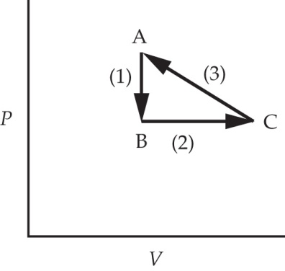

**ANS. FIG. P18.32**

However, when we substitute into the temperature–pressure relation for **stage (1)**, we obtain:



**P18.33** The excess expansion of the brass is



(a) The rod contracts more than the tape to a length reading



(b)



**P18.34** At 0°C, mass *m* of gasoline occupies volume the density of the gasoline is



At temperature above 0*°*C, the same mass of gasoline occupies a larger volume the density of the gasoline is which is slightly smaller than



For the same volume of gasoline, the difference in mass between gasoline at 0°C and gasoline at 20.0°C is



**P18.35** (a) and



For very small changes in *V* and *ρ*, this can be expressed as



(b)



(c) For water we have



(d)



**P18.36** (a) From *PV* = *nRT*, the volume is



Therefore, when pressure is held constant,



Thus, or



(b) At *T* = 0°C = 273.15 K, this predicts



Experimental values are:

(c)



(d)



**P18.37** (a) From ANS. FIG. P18.37, we see that the change in area is

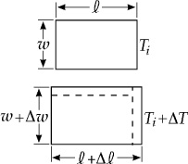

**ANS. FIG. P18.37**



Since and Δ*w* are each small quantities, the product will be very small. Therefore, we assume .



Since and



we then have



and since



(b) The approximation assumes or Another way of stating this is



**P18.38** The angle of bending *θ*, between tangents to the two ends of the strip, is equal to the angle the strip subtends at its center of curvature. (The angles are equal because their sides are perpendicular, right side to the right side and left side to left side.)

(a) The definition of radian measure gives



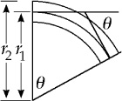 and By subtraction,



**ANS. FIG. P18.38**



(b) In the expression from part (a), *θ* is directly proportional to and also to . Therefore, *θ* is zero when either of these quantities becomes zero.



(c) The material that expands more when heated contracts more when cooled, so It is fun to demonstrate this with liquid nitrogen.



**P18.39** (a)



(b) The coefficient of linear expansion of copper, 17.0 × 10–6 °C–1, is greater than that of steel, 11.0 × 10–6 °C–1, so the copper rod should start with a smaller length. Since the difference between the lengths of the two rods is to remain constant, we require



which gives



Now, with at 0°C, we obtain by substitution,



or



**P18.40** (a)



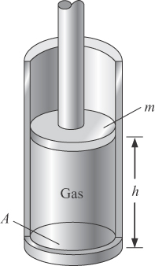 (b) On the piston,

**ANS. FIG. P18.40**



(c) In equilibrium,



Therefore,



or



where we have used *V* = *hA* as the volume of the gas.

**P18.41** We compute the moment of inertia from



and since



Thus



(a) With and , we find for Cu:



(b) With and , we find for Al:



**P18.42** (a)



(b)



**P18.43** Visualize the molecules of various species all moving randomly. The net force on any section of wall is the sum of the forces of all of the molecules pounding on it.

For each gas alone, and and etc.



For all gases,



Also, therefore,



Challenge Problems

**P18.44** (a) Let *xL* represent the distance of the stationary line below the top edge of the plate. The normal force on the lower part of the plate is and the force of kinetic friction on it is up the roof. Again, acts down the roof on the upper part of the plate. The near-equilibrium of the plate requires



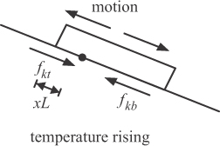

ANS. FIG. P18.44 (a)

and the stationary line is indeed below the top edge by



(b) With the temperature falling, the plate contracts faster than the roof. The upper part slides down and feels an upward frictional force The lower part slides up and feels downward frictional force The equation is then the same as in part (a) and the stationary line is above the bottom edge by .



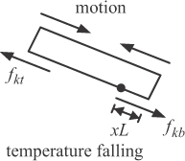

ANS. FIG. P18.44 (b)

(c) Start thinking about the plate at dawn, as the temperature starts to rise. As in part (a), a line at distance *xL* below the top edge of the plate stays stationary relative to the roof as long as the temperature rises. The point *P* on the plate at distance *xL* above the bottom edge is destined to become the fixed point when the temperature starts falling. As the temperature rises, point *P* on the plate slides down the roof relative to the upper fixed line from (*L* – *xL* – *xL*) to , a change of The point on the roof originally under point *P* at the beginning of the expansion moves down not quite as much from (*L* – *xL* – *xL*) to relative to the upper fixed line; a change of When the temperature drops, point *P* remains stationary on the roof while the roof contracts, pulling point *P* back by approximately  
. Therefore, relative to the upper fixed line, point *P* has moved down the roof Its displacement for the day is



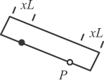

ANS. FIG. P18.44 (c)

At dawn the next day the point *P* is farther down the roof by the distance It represents the displacement of every other point on the plate.



(d)



(e) If , the forces of friction reverse direction relative to parts (a) and (b) because the roof expands more than the plate as the temperature rises and less as the temperature falls. The diagram in part (a) then applies to temperature falling and the diagram in part (b) applies to temperature rising. A point on the plate *xL* from the top of the plate (which becomes the upper fixed line later when the plate contracts) moves upward from the lower fixed line by , and when the temperature drops, the upper fixed line of the plate is carried down the roof by so the net change in the plate’s position is same as before (up to a sign because now ).



**P18.45** See ANS. FIG. P18.45. Let 2*θ* represent the angle the curved rail subtends. We have



and



Thus,



From Table 19.1, and Δ*T* = 25.0°C – 20.0°C = 5.00°C. We must solve the transcendental equation



If your calculator is designed to solve such an equation, it may find the zero solution. Homing in on the nonzero solution gives, to five digits,



Now,



This yields , a remarkably large value compared to



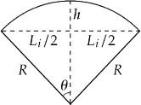

ANS. FIG. P18.45

**P18.46** Each half of the spherical container is a particle in equilibrium.



where *σ* is the yield strength of the steel. Find the mass of the steel sphere:



Find the pressure of the helium in the tank:



Substitute into the previous equation:



Find the buoyant force on the balloon:



where we use the pressure of helium in the balloon *P* = *P*0 = atmospheric pressure.

Find the net force on the balloon and tank:



Evaluate the brackets:



Because the net force is negative, the balloon cannot lift the tank. If we can vary the strength of the steel, let’s find out how strong the steel must be by evaluating *σ* to make the net force positive. We want the following to be true:



Manipulating this inequality gives,



|  |
| --- |
| **ANSWERS TO QUICK-QUIZZES** |

**1.** (c)

**2.** (c)

**3.** (c)

**4.** (c)

**5.** (a)

**6.** (b)

|  |
| --- |
| **ANSWERS TO EVEN-NUMBERED PROBLEMS** |

**P18.2** (a) 2109°F, 195 K (b) 98.6°F, 310 K

**P18.4** (a) 2320°F (b) 77.3 K

**P18.6**  to the right at 78.2° below the horizontal



**P18.8** 55.0°C

**P18.10** (a) 0.109 cm2 (b) increase

**P18.12**  ]



**P18.14** Required T = −376° C is below absolute zero.

**P18.16** (a) 2.52 × 106 N/m2; (b) the concrete will not fracture

**P18.18** In each pump-up-and-discharge cycle, the volume of air in the tank doubles. Thus 1.00 L of water is driven out by the air injected at the first pumping, 2.00 L by the second, and only the remaining 1.00 L by the third. Each person could more efficiently use his device by starting with the tank half full of water, instead of 80% full.

**P18.20** (a) 1.17 × 10−3 kg; (b) 11.5 mN; (c) 1.01 kN; (d) molecules must be moving very fast

**P18.22** 6.64 × 10–27 kg

**P18.24** 6.58 × 106 Pa

**P18.26**



**P18.28** Scenario (ii) is better for a dive of this depth.

**P18.30** 35.016 m

**P18.32** 95.0°; T falls below 100°C, so steam condenses, and the expensive apparatus falls (assuming that the boiling point does not change significantly with the change in pressure).

**P18.34** 0.523 kg

**P18.36** (a) ; (b) 3.66 × 10−3 K−1; (c) this agrees within 0.06% of the tabulated value; (d) , this agrees within 0.2% of the tabulated value



**P18.38** ; (b) In the expression from part (a), *θ* is directly proportional to and also to . Therefore, *θ* is zero when either of these quantities becomes zero; (c) the bimetallic strip bends the other way



**P18.40** (a) Particle in equilibrium model; (b) On the piston, (c)



**P18.42** (a) No torque acts on the disk so its angular momentum is constant. Yes: it increases. As the disk cools, its radius, and hence, its moment of inertia decrease. Conservation of angular momentum then requires that its angular speed increase; (b) 25.7 rad/s

**P18.44** (a) (b) With the temperature falling, the plate contracts faster than the roof. The upper part slides down and feels an upward frictional force The lower part slides up and feels downward frictional force The equation is then the same as in part (a), and the stationary line is above the bottom edge by ; (c) See P18.44 (c) for the full explanation; (d) 0.275 mm; (e) The plate creeps down the roof each day by an amount given by the same expression (with *α*2 and *α*1 interchanged).



**P18.46** No; steel would need to be 2.30 times stronger.